**Shoal Creek Watershed Protection Plan**

**Draft Outline – Table of Contents**

Prepared in cooperation with the Texas Commission on Environmental Quality

and the U.S. Environmental Protection Agency

March 25, 2019 - DRAFT

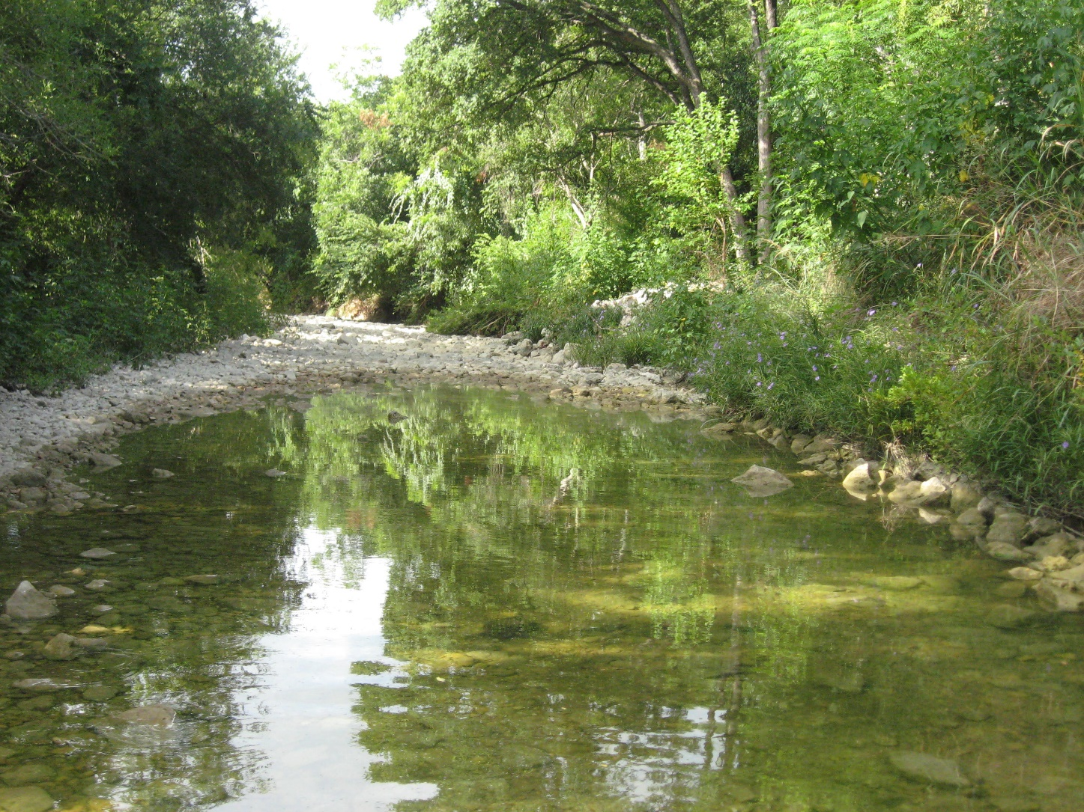







**DRAFT TABLE OF CONTENTS – Shoal Creek Watershed Plan 3-25-19**

**Acknowledgements**

**Executive Summary**

**List of Acronyms and Abbreviations**

**List of Figures**

**List of Tables**

**Nine Element Crosswalk**

1. **Introduction**
   1. **Watershed Characterization Summary**
      1. **Watershed Vital Statistics**
      2. **Water Quality**
         1. **Element A – Identification of Causes and Sources of Pollution**
         2. **Comparison to Other Urban Streams**
      3. **Stream Erosion**
      4. **Riparian Habitat**
      5. **Flood Issues**
   2. **Stakeholder Committee Organization and Structure**
   3. **Stakeholder Goals**
   4. **Stakeholder Process**
   5. **Watershed Planning Approach**
2. **Water Quality Modeling Summary**
   1. **Existing conditions**
   2. **Future land use conditions**
   3. **Comparison to City of Austin Models**
3. **Watershed Health Potential Management Strategies – Element C**
   1. **On-site**
   2. **Regional**
   3. **Regulatory**
   4. **Educational**
   5. **Incentives/Financial**
   6. **Policy**
4. **Watershed Protection Plan Summary & Implementation**
   1. **Plan Summary**
   2. **Estimation of Load Reductions (Element B)**
      1. **On-site**
      2. **Regional**
      3. **Multi-Purpose**
      4. **Regulatory**
      5. **Educational**
      6. **Incentives/Financial**
      7. **Other**
   3. **Element D - Technical and Financial Assistance to Implement the Plan**
      1. **Local**
      2. **State**
      3. **Federal**
      4. **Other**
   4. **Element F – Schedule for Management Strategy Implementation**
      1. **Management Measure Prioritization**
      2. **Short Term**
      3. **Long Term**
   5. **Element G – Management Strategy Milestones to Assess Implementation**
   6. **Element H – Load Reduction Criteria**
   7. **Element I – Monitoring Evaluate Implementation Effectiveness**
5. **Education and Outreach to Enhance Public Understanding of the Plan (Element E)**
6. **References**

**7.0 TBD if needed**

**Appendix A – Watershed Characterization Report**

**Appendix B – Final Water Quality Modeling Report**

**Appendix C – Link to Stakeholder Meeting Materials**